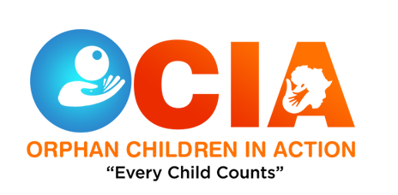
Ocia Volunteer
Engagement & Activities

Purpose and Aims of the Role
Could you spare 2-3 hours twice a month to help turn a child's frown upside down?
Our volunteers help children from 4-5 years old to 16 here in Uganda. There are no special requirements to become a helper if you are willing to have fun and can show commitment and consistency in the Childs life through regular fun outings. Most of our Ocians have been badly let down by an adult in their life and can benefit from having a positive adult role model.
What will I be doing?
That is entirely up to you and the child - encourage them to try new activities and explore new places together.

What qualities do I need?
- Reliability and commitment
- Non-Judgemental
- Respect for confidentiality
- Enthusiasm and fun
When will I be needed?
- Twice a month for 2-3 hours, after school and on weekends
- Flexibility is key! Outings will be scheduled between you and the family to fit around both you and the Childs other commitments.
- A minimum commitment of one year is required
What will I gain from the role?
- A chance to try new activities or activities you haven't done since your childhood
- A sense of satisfaction that you have positively impacted on a child in a community in which you live.
- Quarterly training can update your own skill set and knowledge
What support will I be given?
- Induction, Substance and Alcohol and Basic Child Protection Training
- Support & Guidance will be given by email & telephone. An on-call service will also be provided for evenings & weekends.
- Access to further Quarterly Training to enhance your knowledge and befriending experience
Additional Information
YOU must be 19 years old to be a volunteer. This role is also subject to you providing 2 references, attending a short interview, becoming a member of the PVC Scheme and completing the Befriend a Child Training Weekend.

Contact details
Enock Kagimu - Head of Operational Support Services
Main office:Ocia Organisation,Nansana,Wakiso District-Uganda,
Phone: +256772087266 Email: enock@ociachildrenafrica.org

Ocia Organisation, a Charitable Company Limited by guarantee.
Registered in Uganda Company number 299928 Registered charity number UG005467

